**Western Australian Certificate of Education**

**Semester 2 Examination**

**Question/Answer Booklet**

Please place your student identification label in this box (if required)

**COMPUTER**

**SCIENCE**

## Year 11 ATAR: Unit 1 & 2

|  |  |  |  |  |  |  |  |  |  |  |  |  |
| --- | --- | --- | --- | --- | --- | --- | --- | --- | --- | --- | --- | --- |
| Student Number: | In figures |  |  |  |  |  |  |  |  |  |  |  |
|  | In words |  |  |  |  |  |  |  |  |  |  |  |
|  |  |  |  |  |  |  |  |  |  |  |  |  |

## Time allowed for this paper

Reading time before commencing work: ten minutes

Working time: three hours

## Materials required/recommended for this paper

***To be provided by the supervisor***

This Question/Answer booklet

Source booklet

***To be provided by the candidate***

Standard items: pens, pencils, eraser, correction fluid/tape, ruler, highlighters

Special items: non-programmable calculators approved for use in this examination, Mathomat and/or Mathaid and/or any system flowchart template

**Important note to candidates**

No other items may be taken into the examination room. It is **your** responsibility to ensure that you do not have any unauthorised material. If you have any unauthorised material with you, hand it to the supervisor **before** reading any further.

## Structure of this Paper

|  |  |  |  |  |  |
| --- | --- | --- | --- | --- | --- |
| Section | Number of questions available | Number of questions to be answered | Suggested working time (minutes) | Marks available | Percentage of examination |
| Section One:  Short answer | 20 | 20 | 70 | 78 | 40 |
| Section Two:  Extended answer | 4 | 4 | 110 | 122 | 60 |
|  |  |  |  | **Total** | 100 |

## Instructions to candidates

1. The rules for the conduct of the Western Australian Certificate of Education ATAR course examinations are detailed in the *Year 12 Information Handbook 2019*. Sitting this examination implies that you agree to abide by these rules.
2. Write your answers in the spaces provided in this Question/Answer booklet. A blue or black pen should be used. Wherever appropriate, fully labelled diagrams, tables and examples should be used to illustrate and support your answers.
3. You must be careful to confine your answers to the specific questions asked and to follow any instructions that are specific to a particular question. Where no specific instructions are given, you should feel free to use a range of formats to express your knowledge and understandings.
4. Additional working space pages at the end of this Question/Answer booklet are for planning or continuing an answer. If you use these pages, indicate at the original answer, the page number it is planned/continued on and write the question number being planned/continued on the additional working space page.

## Section One: Short answer 40% (78 marks)

This section contains **twenty (20)** questions. You must answer **all** questions. Write your answers in the spaces provided.

Supplementary pages for the use of planning/continuing your answer to a question have been provided at the end of this Question/Answer booklet. If you use these pages to continue an answer, indicate at the original answer where the answer is continued, i.e. give the page number.

Suggested working time: 70 minutes.

1. (2 marks)

Outline the difference between RAM and ROM.

1. (1 mark)

State the type of authentication that uses physiological or behavioural characteristics.

1. (4 marks)

The HP Pavilion All-in-One desktop personal computer has the following specifications:

Intel® Core™ i5-8400T   
8GB RAM  
1TB HDD storage  
NVIDIA GeForce MX130 graphics (2GB GDDR5)  
FHD BrightView WLED-backlit touch screen (1920 x 1080)  
HP Truevision FHD IR camera with dual array digital microphone  
Wireless keyboard and mouse

Identify a hardware component from the above computer system designed for the following specific purpose:

Input

Output

Processing

Primary storage

1. (6 marks)

Describe the function of the following components in the central processing unit (CPU).

Control unit

Arithmetic logic unit (ALU)

System clock

1. (5 marks)

Outline the steps of the boot process from power up to OS booting.

1. (3 marks)

Use the image below to answer the following questions about spreadsheet functions.

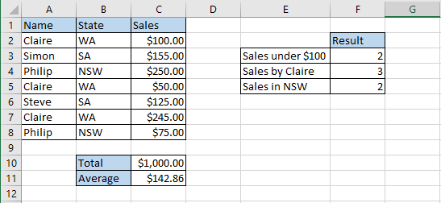

State the formula that would be contained in the following cells:

C10

C11

F3

1. (3 marks)

Define the following database terms:

Relation

Data integrity

Data redundancy

1. (6 marks)

A problem exists in this entity relationship diagram (ERD). Illustrate how you would resolve this issue in the space below. Show only entities, relationships, cardinality, primary and foreign keys. No non-key attributes are needed.

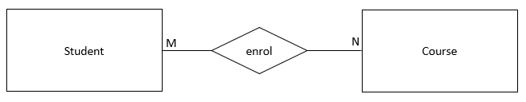

|  |
| --- |
|  |

1. (6 marks)

Describe the purpose of the following types of software and give an example for each.

Operating system

Example:

Utility software

Example:

1. (3 marks)

Explain the difference between freeware and open source software licences.

1. (4 marks)

The Dataflow Diagram below has several errors. Outline **four** errors in the diagram.

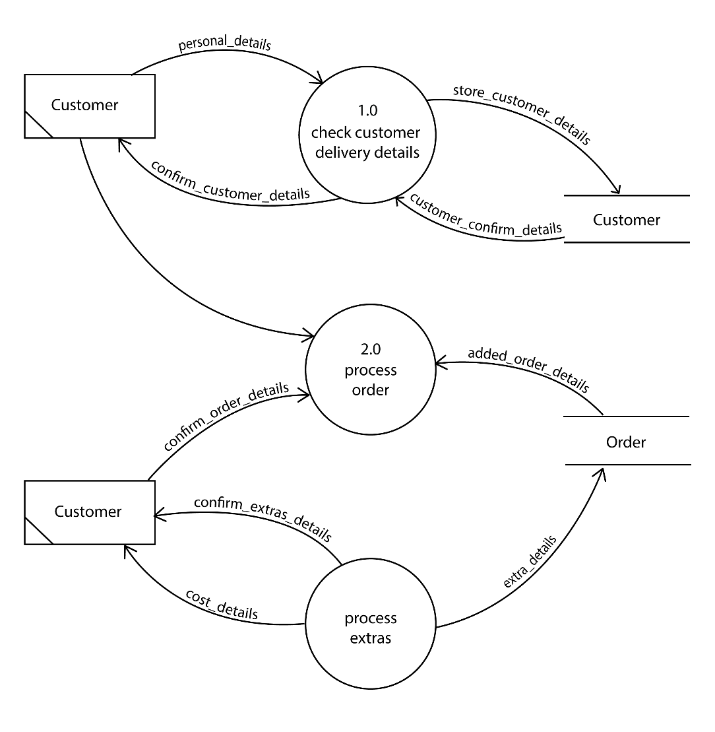

One

Two

Three

Four

1. (1 mark)

State **one** reason for appropriately naming a variable in your code.

1. (2 marks)

Describe the reason a programmer would use a test first iteration over a test last iteration.

1. (3 marks)
2. Convert the following binary number to a decimal number. (1 mark)

01101100 Base 2

1. Convert the following hexadecimal number to a decimal number. (1 mark)

23B Base 16

1. Convert the following decimal number to a binary number. (1 mark)

178 Base 10

1. (6 marks)

Describe the function of the following network components:

Router

Switch

Modem

1. (6 marks)

Describe the following transmission media and give an advantage for its use.

Wireless

Advantage

Fibre Optic

Advantage

1. (2 marks)

Ethernet has become the most popular and widely deployed Local Area Network (LAN) technology in the world. State **two** reasons for this.

One

Two

1. (6 marks)

Expand the acronym and describe the purpose of the following types of communication protocols.

The first one has been done for you.

HTTP: *Hypertext Transfer Protocol*

Purpose: *HTTP protocol specifies how client’s request data will be constructed and sent to the server and how the server respond to these requests.*

FTP

Purpose

SMTP

Purpose

1. (2 marks)
2. State one ethical responsibility of software developers. (1 mark)

1. State one ethical responsibility of software users. (1 mark)

1. (7 marks)

Use the image below to answer all parts of this question about databases.  
  
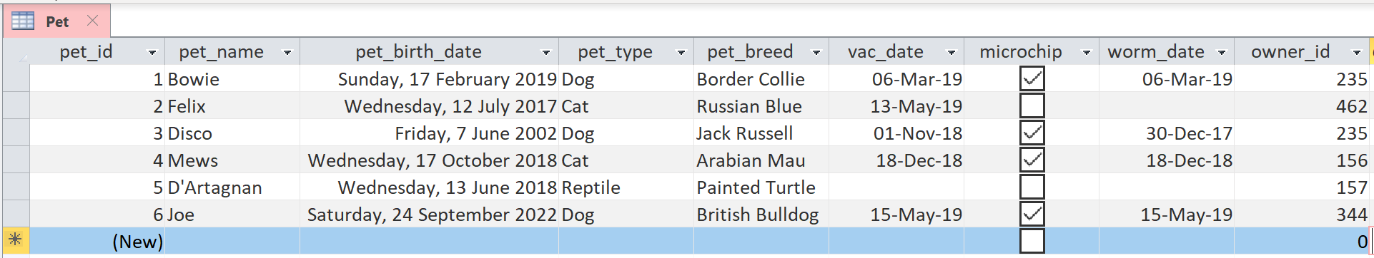

1. Identify which data type you would use for the following: (3 marks)

pet_id

pet_type

microchip

1. In the pet_birth_date field an obvious data entry error has been made. Identify the error. (1 marks)

1. State a validation rule that could be used to avoid this issue. (1 marks)

1. The Central Vet Clinic would like to develop some software to manage pet bookings. State two factors affecting the development of software. (2 marks)

One

Two

**END OF SECTION ONE**

## Section Two: Extended Answer 70% (122 Marks)

This section has **four (4)** questions. Answer all questions. Write your answers in the spaces

provided.

Supplementary pages for the use of planning/continuing your answer to a question have been provided at the end of this Question/Answer booklet. If you use these pages to continue an answer, indicate at the original answer where the answer is continued, i.e. give the page number.

Suggested working time: 110 minutes.

1. (36 marks)

Refer to the Source booklet to answer this question.

* 1. The Central Vet Clinic have begun planning their new system. A system analyst suggested they use the system development life cycle (SDLC) as a development methodology. Identify the first two stages of the SDLC and describe what happens in each stage. (6 marks)

First Stage

Description

Second Stage

Description

* 1. A project manager discussed the concepts of planning, scheduling, budgeting and tracking. Describe why it is important to track a project’s progress. (2 marks)

* 1. Use the source booklet to complete the unfinished Context Diagram for the Central Vet Clinic appointment system below. (11 Marks)



* 1. Use the source booklet to create the Level 0 Data Flow Diagram (DFD) for the system below. (17 Marks)



Use the source booklet to **answer the following question** for the Central Vet Clinic.

1. (21 marks)
   1. Complete the Entity Relationship (ER) Diagram for this database in the area below using Chen’s notation. Ensure you resolve all many to many relationships. Include Primary keys, Foreign keys, cardinality and relationships. You do not need to include non-key fields. (14 marks)

|  |
| --- |
|  |

* 1. State one benefit of using a relational database to store The Central Vet Clinic’s data.

(1 mark)

Use the image below to answer this next question.

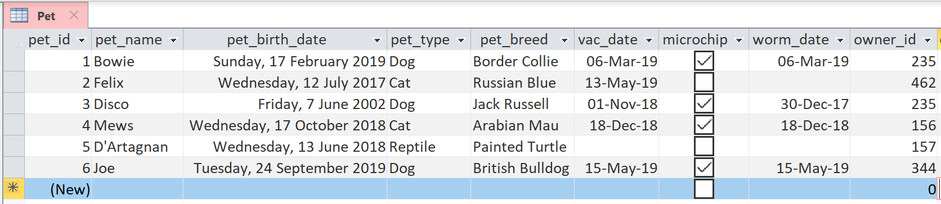

* 1. Refer to the Pet table, using Structured Query Language (SQL), write a query that will return all fields from the Pet table which have been microchipped. (3 marks)

* 1. Refer to the Pet table, using Structured Query Language (SQL), write a query that will return the pet’s name, type of pet and date of birth fields if the pet is a dog from the Pet table. (3 marks)

1. (39 marks)

When animals arrive at the Central Vet Clinic for their appointment, they are weighed so that the Vet knows dosage for medication. Unfortunately, the software the clinic is using is from overseas and only allows staff to input weights using pounds and not kilograms.

The clinic has asked that you create an algorithm which will provide a conversion from kilograms to pounds so that they can enter the weight in pounds into the system. The formula to convert from kilograms to pounds is:

Weight(pounds) = weight(kilograms) * 2.20462262185

Hint: the international standard symbol for pounds is lb

* 1. Use pseudocode to design an algorithm to convert the pet weight measured in kilograms to a pet weight in pounds.

Your algorithm should: (9 marks)

* + - input the appointment reference number (appointmentRefNum)
    - input the pet’s name (petName)
    - input the pet weight in kg (petWeightKg)
    - check to ensure the weight is a valid number (above 0kg and less than 200kg)
    - output an error message if an invalid number is entered
    - convert the pet weight to pounds (petWeightLb)
    - output the appointment reference number and the pet weight in pounds   
      (eg. Fido weighs 250lb)

**PAGE LEFT BLANK INTENTIONALLY**

Use the source booklet to **answer the following question** for the Central Vet Clinic.

* 1. Complete the following flowchart using the algorithm on page 3 of the source booklet. (10 marks)

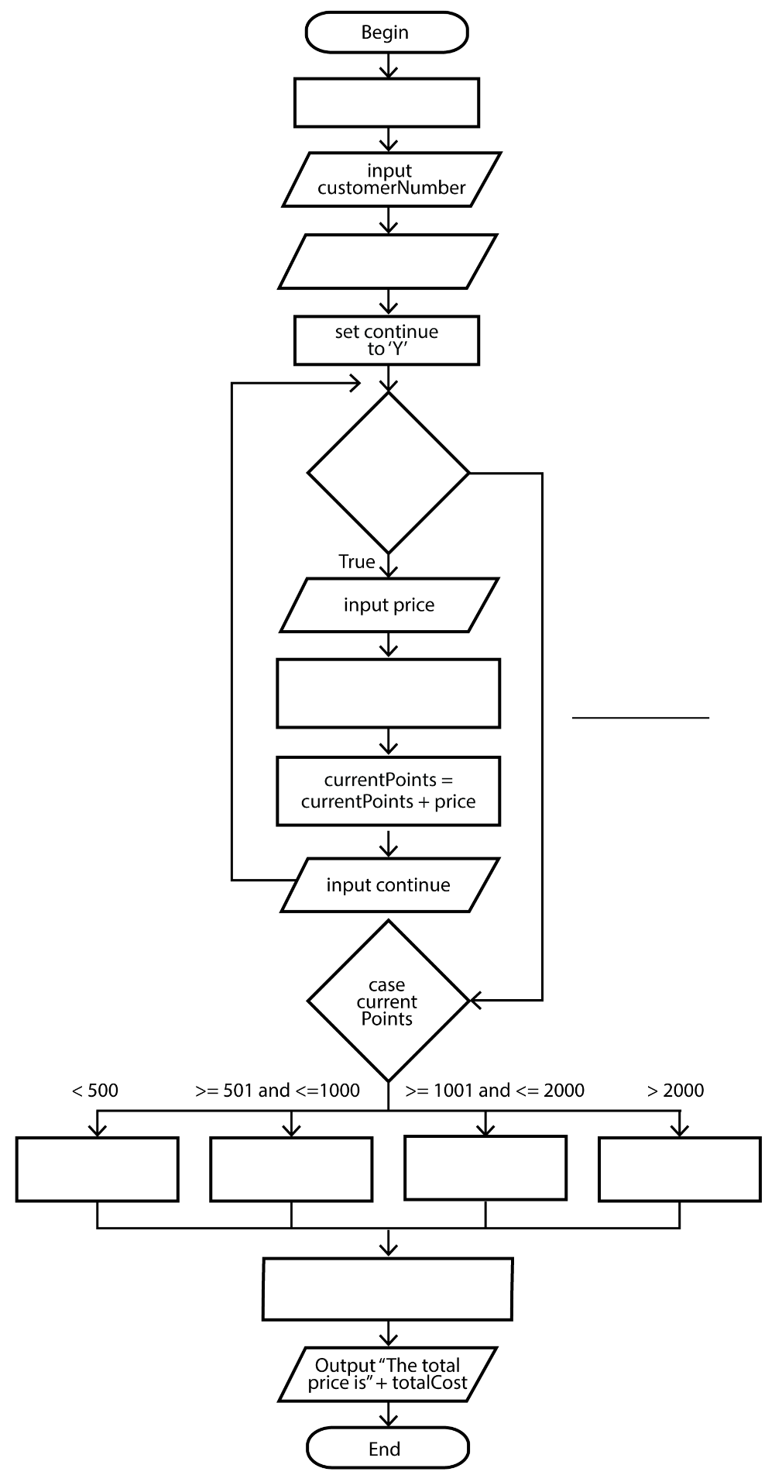

Use the source booklet to **answer the following question** for the Central Vet Clinic.

* 1. Use the algorithm on page 4 of the source booklet together with the data in the table below to complete the trace table below. Part of the trace table has been completed for you. (13 marks)

|  |  |  |  |
| --- | --- | --- | --- |
| **Customer Number** | **Current Points** | **Appointment details** | **Price** |
| 2822 | 150 | Sterilisation  Worming | 360  40 |

|  |  |  |  |  |  |  |  |  |  |
| --- | --- | --- | --- | --- | --- | --- | --- | --- | --- |
| **Line No** | **total Price** | **customer Number** | **current Points** | **continue** | **Continue = ‘Y’** | **price** | **discount** | **Total Cost** | **Output** |
| 1 | 0 |  |  |  |  |  |  |  |  |
| 2 |  | 2822 |  |  |  |  |  |  |  |
| 3 |  |  | 150 |  |  |  |  |  |  |
| 4 |  |  |  | Y |  |  |  |  |  |
| 5 |  |  |  |  | TRUE |  |  |  |  |
|  |  |  |  |  |  |  |  |  |  |
|  |  |  |  |  |  |  |  |  |  |
|  |  |  |  |  |  |  |  |  |  |
|  |  |  |  |  |  |  |  |  |  |
|  |  |  |  |  |  |  |  |  |  |
|  |  |  |  |  |  |  |  |  |  |
|  |  |  |  |  |  |  |  |  |  |
|  |  |  |  |  |  |  |  |  |  |
|  |  |  |  |  |  |  |  |  |  |
|  |  |  |  |  |  |  |  |  |  |
|  |  |  |  |  |  |  |  |  |  |
|  |  |  |  |  |  |  |  |  |  |
|  |  |  |  |  |  |  |  |  |  |

* 1. The Central Vet Clinic don’t understand the purpose of internal documentation. Describe this term and suggest who might use it. (3 marks)

Purpose

User

* 1. When testing some code at The Central Vet Clinic, it returned a run-time error. State one cause of such and error. (1 marks)

* 1. A system analyst suggested the Vet Clinic’s new system should be developed using an object-oriented programming language. (3 marks)

i. Identify one object-oriented language. (1 marks)

ii. State two benefits for using an object-oriented language. (2 marks)

Use the source booklet to **answer the following question** for the Central Vet Clinic.

1. (26 marks)

The Central Vet Clinic have access to the internet and are upgrading their network to include the ability for the staff to enter appointment details about the pets on mobile tablet devices.

They have the following hardware network components:

* Firewall
* Router
* Modem
* Switch
* Wireless access point
* Wired network printer
* Network attached storage
* Desktop computer
* 4 x Tablet devices
  1. Use the space below to create a network diagram for The Central Vet Clinic.

(10 marks)

|  |
| --- |
|  |

* 1. State the network topology have you illustrated in question 24(a). (1 marks)

* 1. The Central Vet Clinic has always struggled to get internet signal in the Kennel Room at the back of the block. The Kennel Room is approximately 45 metres away from the Office. Suggest which transfer media would be most appropriate and state two reasons to justify your answer. (3 marks)

Selected media

Reason one

Reason two

* 1. The Central Vet Clinic’s internet service provider suggested that they should typically be getting a minimum bandwidth of 30 Mbps for their broadband internet service.

Define the following terms expanding all acronyms: (4 marks)

Bandwidth

Mbps

* 1. The Central Vet Clinic are concerned about the security of their client’s data especially as they have an internet connection.

Recommend two methods they can use to ensure the security of information over the internet. (2 marks)

One

Two

* 1. The Central Vet Clinic stated that all “malware is the same”. Help educate them by distinguishing the main characteristic of the following malware and suggest a protection method to prevent infection. (6 marks)

Worms

Protection method

Trojans

Protection method

Spyware

Protection method

**END OF EXAMINATION**

**END OF EXAMINATION**

Spare lined paper for long answers or corrections